Assessment of Electro-Oxidation as Pre- and Post-Treatment for Improving Anaerobic Digestion and Stabilisation of Waste Activated Sludge

Cristian B. Arenas, Ruben González, Judith González, Jorge Cara, George Papaharalabos, Xiomar Gómez, E. Judith Martínez*

Chemical and Environmental Bioprocess Engineering Group, Natural Resources Institute (IRENA), University of León. Av. de Portugal 41, 24009, León, Spain.

e-mail of the corresponding author: ejmartr@unileon.es

Abstract
This study evaluates the effects of electro-oxidation as a means for enhancing sludge stabilisation. Boron-doped diamond electrodes were used to treat waste activated sludge and digestate under different operating parameters (current density, conductivity, pH, and time). Electro-oxidation runs affected the solubilisation of organic matter, which seemed to improve anaerobic digestion and dewaterability characteristics.
Among the tested parameters, pretreating sludge via electro-oxidation under alkaline conditions (Treatment T5) resulted in the highest increase in soluble organic material compared to that in the control, with total organic carbon (TOC) and soluble chemical oxygen demand (COD) values of 2753 and 7819 mg L^{–1}, respectively (control TOC and COD values were 385 and 1073 mg L^{–1}). This pretreatment also achieved a high hydrolysis rate (higher concentration in volatile fatty acids) with a concomitant increase in methane yield (approximately 18%). On the other hand, the application of electro-oxidation as a post-treatment for improving digestate dewaterability resulted in noticeable changes in the release of water during drying due to protein and aliphatic matrix modification of the sample.

Keywords: electrochemical oxidation; sludge management; solubilisation; digestion performance; dewaterability; FTIR

1. Introduction

Wastewater treatment based on the activated sludge process is the most widely applied technology to prevent water pollution. The treatment and disposal of biosolids may represent up to 50% of plant operating costs, and it is estimated that the disposal of this sludge is responsible for almost 40% of total greenhouse gas emissions from wastewater treatment plants (WWTPs; Appels et al., 2008; Gherghel et al., 2019). As such, sustainable technologies that promote valorisation options instead of land disposal for sludge management have great potential for reducing the final disposal amount of sludge, and producing better-quality material, thus reducing the impact on the environment (Canziani and Spinosa, 2019).

Anaerobic digestion is a well-known and effective process for sludge stabilisation and valorisation. Anaerobic digesters in WWTPs usually treat a mixture of primary and secondary (waste activated) sludge. Waste activated sludge (WAS) consists of filamentous micro-organism flocs, ionic components, colloids, mineral particles, and extracellular polymeric substances (EPS; Dai et al., 2013; Shao et al., 2010) that form complex structures that are difficult to digest (Lafitte-Trouqué and Forster, 2002).

Even though the organic content of sludge, measured as total chemical oxygen demand (COD), is high, the soluble fraction of COD is usually low, with the latter being the organic material accessible to micro-organisms and responsible for initiating the acidogenesis phase. Thus, sludge pretreatment is required to rupture cell walls and facilitate the release of intracellular material into the aqueous phase for accelerating biodegradation and enhancing anaerobic digestion (Kim et al., 2003). Subsequently, several technologies, including mechanical, thermal, ultrasonic, microwave, enzymatic, chemical, and electrochemical oxidation pretreatments were proposed to improve sludge digestibility (Barjenbruch and Kopplow, 2003; Li et al., 2012; Mainardis et al., 2019; Ruffino et al., 2015; Saha et al., 2011; Tedesco et al., 2013; Villamil et al., 2019; Yu et al., 2014).

Besides transforming organic matter into biogas, anaerobic digestion produces a solid–liquid byproduct called digestate that contains increased levels of nutrients and stabilised organic matter with low putrescible potential (Möller, 2012). Digestate management is a key factor for circumventing pollution problems associated with the release of high-risk contaminants into the environment. The adequate disposal of digestates is a challenging task due to their high water content, making transport and storage operations difficult to handle, thus increasing final disposal costs (Bauer et al., 2009). These drawbacks have shifted the research focus on different pretreatment strategies that may aid in the stabilisation of organic material and dewatering (Li et al., 2017; Martínez et al., 2015; Mo et al., 2015). The different pretreatment techniques are not always capable of attaining all needs associated with the water removal of sludge, reducing odours and toxicity, and the removal of pathogens (Bureau et al., 2012). To this extent, electrolysis has recently emerged as an alternative dewatering and stabilising technique. This technology has high capacity for solubilising organics contained in sludge with almost negligible environmental impact, which can reduce the costs for sludge handling and final disposal (Rahmani et al., 2015; Tuan et al., 2012; Xiao et al., 2019).

Electrochemical oxidation or electro-oxidation is an attractive technology for its ability to treat complex organic pollutants under ambient temperatures and pressure conditions (Martinez et al., 2018; Yahiaoui et al., 2018, 2015). Electro-oxidation includes photo-electro-Fenton, electro-Fenton, and anodic oxidation. The latter is considered as an advanced oxidation process with the added advantage of generating in situ hydroxyl radicals (•OH; Markou et al., 2017). Advanced oxidation processes can interact with pollutants by direct electron transfer to the anode surface (M) or through heterogeneous reactive oxygen species that are produced as intermediaries from the oxidation of water to oxygen, including potent physisorbed hydroxyl radicals (•OH) on the anode surface. This radical is denoted as M(•OH) and was generated via Equation (1). Other, less drastic oxidants such as H₂O₂ are derived from M(•OH) dimerisation by Equation (2) (Panizza et al., 2008). However, both oxidation mechanisms may coexist during electro-oxidation processes (Yu et al., 2014). OH radicals can promote sludge breakdown and EPS dissociation via chemical oxidation at very low concentrations.
$M+H_{2}O →M\left(·OH\right)+H^{+}+e^{-}$ (1)

$2M\left(·OH\right) →2MO+H_{2}O_{2}$ (2)

When cells contained in WAS are exposed to an external electric field, there is a build-up of electrical charge on both sides of the cell membrane. This charge overload exceeds the membrane’s elastic resistance and causes its fracture, resulting in the release of organic substances that favour the hydrolysis stage in anaerobic digestion (Salerno et al., 2012).

The objective of this study was to evaluate the effects of electro-oxidation on the characteristics that govern sewage sludge stabilisation. Electro-oxidation was used in two different downstream processes. The first was in WAS pretreatment for improving its solubilisation of organic material and enhancing anaerobic digestion. The second, as post-treatment application, was once sewage sludge had been treated by anaerobic digestion. For the treatment of sewage sludge, a boron-doped diamond (BDD) anode was utilised. Pretreatment efficiency was assessed in terms of the quantity and quality of produced biogas, whereas in the case of post-treatment, efficiency was evaluated using digestate dewatering characteristics, particle size distribution, solubilisation, and changes in main functional groups using FTIR analysis.

2. Material and Methods
2.1. Electrochemical Oxidation Experiments
Pretreatment experiments were carried out using a 150 mL chamber. BDD electrodes were used as anodes, and stainless steel was used as the cathode with a distance of 2 mm between them. Each electrode was a mesh, rectangular in shape (10 × 5 mm) with an effective area of 42 cm². A current density of 6.6 mA cm^{–2} (5 V for 60 min) was applied in all pretreatments. This current density was chosen on the basis of results from previous experiments (Martinez et al., 2018) and previous studies performed in the laboratory to adjust treatment conditions to sludge characteristics (data not shown). Post-treatment tests were performed by employing a 75 mL flow cell (Pro-Aqua Diamond Electrode Production Ltd, GmbH). This cell contained a BDD anode and cathode with an effective area of 42 cm² and 2 mm distance between electrodes. This cell was used in this experiment setup because of the low evolution of gases from the bulk sludge, which allowed good performance of the cell. This was not the case of the pretreatment experiments, where high degradability of raw sludge caused excessive foaming associated with gas evolution, thus making its use unfeasible. Current density inputs were in the range from 5.5 to 18.8 mA cm^{–2} (15–25 V for a treatment time ranging from 5 to 60 min). Experiments were conducted under batch conditions at room temperature (25 ± 1 °C).
Pre- and post-treatment tests were labelled in accordance with conditions set for experiments as shown in Table 1. WAS used in pretreatment experiments was collected from the dissolved air flotation unit of the WWTP (León, Spain). This sludge had a total solids (TS) content of 21.8 g L^{–1} and a volatile solids (VS) concentration of 14.4 g L^{–1}. Digested sludge (or digestate) was used in the post-treatment tests. This sludge was obtained from a batch laboratory reactor treating WAS that had not previously been submitted to any type of pretreatment. This digestion lasted 40 days, after which the digestate was collected and concentrated to attain TS content of 22.0 g L^{–1} (VS content of 10.1 g L^{–1}). Solubilisation and the effect of electro-oxidation were measured. When evaluating post-treatment efficiency, dewaterability characteristics were also analysed. Na₂SO₄ was added as supporting electrolyte to adjust conductivity (Jiang et al., 2010). An alkaline solution of 0.2 M NaOH was used to increase pH to a value of 10.
Table 1. Pre- and post-treatment experiment conditions. WAS, waste activated sludge.

WAS Pretreatment | Characteristics | Voltage (Volts) | Current (mA/cm²) | Time (min)
T1 | Control | 5 | 6.6 | 60
T2 | 3 g L^{–1} Na₂SO₄ | 5 | 6.6 | 60
T3 | 6 g L^{–1} Na₂SO₄ | 5 | 6.6 | 60
T4 | pH =4, H₂SO₄ | 5 | 6.6 | 60
T5 | pH=10, alkaline solution | 5 | 6.6 | 60
Digestate Post-Treatment
P1 | Control | 15 | 5.5 | 5
P2 | pH = 10, alkaline solution | 15 | 10.7 | 5
P3 |  | 25 | 11.4 | 5
P4 | pH = 10, alkaline solution | 25 | 18.8 | 5
P5 |  | 25 | 6.8 | 60

2.2. Anaerobic Digestion Experiments
Batch digestion experiments were used to study the production of methane from WAS after electro-oxidation pretreatment. Digested sludge was used as inoculum and obtained from the anaerobic digester of the local WWTP (León, Spain). This sludge had a TS content of 19.3 g L^{–1} and VS concentration of 11.4 g L^{–1}.

Experiments were carried out in triplicate using 250 mL Erlenmeyer flasks. Flasks were filled with inoculum and substrate at a 1:1 ratio (substrate/inoculum, expressed in VS). Tap water was added to complete the volume. Gas production and composition were periodically measured. Gas volume was measured using a bottle gasometer, and corrected to standard temperature and pressure (STP, 0 ºC and 100 kPa). A blank reactor containing inoculum was used to subtract background gas production. Reactors were placed in a water bath to maintain a set temperature (37 °C ± 1). Agitation was provided through magnetic stirrers. Digestion systems were labelled as shown in Table 1, where characteristics of the different batch tests are described.

Methane production was fitted to the modified Gompertz equation:
$P_{(t)}=P_{max}∙\exp\left[-\exp\left({R_{max}∙e}/{P_{max}}\right)\left(λ-t\right)+1\right]$, (3)

where P_{(t)} is the cumulative methane yield (L kg^{–1} VS); P_{max} is the maximal methane yield (L kg^{–1} VS), R_{max} is the maximal methane production rate (L kg^{–1} VS d^{–1}), λ is lag phase time (d), and e is Euler’s number (approx. 2.718).

2.3. Analytical Techniques
TS, VS, and pH were measured as described in APHA (2005). Total organic carbon (TOC) was analysed using a high-performance analyser multi-N/C®, bringing the sample to 980 ºC, and inorganic carbon was measured by sample acidification using a solution of 10% phosphoric acid (H₃PO₄) according to Shimadzu (2017). Organic carbon was calculated by the difference between total carbon and inorganic carbon. COD was measured using commercial kit tubes LCK 514 (low range 1000–10,000 mg L^{–1}, Hach), measured in a DR 3900 spectrophotometer (Hach).
Biogas was measured using gas chromatography (CP-3800 GC, Varian) with a thermal conductivity detector (TCD). Measurement of H₂, CH₄, CO₂, N₂, and O₂ was performed using a HayeSep Q 80/100 column of 4 m length attached to a molecular sieve (1.0 m × 1/8 in. × 2.0 m) column. The carrier gas was helium, and the columns operated at pressure of 331 kPa and temperature of 50 ºC.
Volatile fatty acids (VFAs) were analysed using a gas chromatograph (450-GC, Bruker) with a flame ionisation detector (FID) equipped with a Nukol capillary column (30 m × 0.25 mm × 0.25 mm) supplied by Supelco. The carrier gas was helium. Injector and detector temperatures were 220 and 250 °C, respectively. Oven temperature was set to 150 °C for 3 minutes and increased to 180 °C with a ramp-up of 10 °C min^{–1}. Methods for measuring biogas composition and VFA concentration are described in detail elsewhere (Martínez et al., 2019).
Particle size analysis was carried out using a laser diffraction particle size analyser (LS 13 320, Beckmann Coulter). This device was equipped with an optical bench and a universal liquid module to measure the size distribution of particles. The scatter generated by particles was estimated on the basis of the Fraunhofer optical model. Samples were prepared by diluting them in tap water for analysis. Each sample was measured ten times.
Sludge dewaterability characteristics were measured after anaerobic digestion of WAS. Solid removal was expressed as the percentage of volatile solid removal (%) and calculated on the basis of the following equation:
$\left(\%\right) VS removal= {{VS}_{digestate}-{VS}_{ digestate after EO }}/{{VS}_{digestate}}$, (4)
where VS _{digestate} is the volatile solid content of the raw digestate, and VS _{digestate after EO} is the volatile solids of the digestate after each electro-oxidation treatment, quantified in g kg^{–1}.
Capillary suction time (CST) was measured using 10 mL of digestate and samples obtained from post-treatment tests. The sample was poured into a stainless-steel tube (1.0 cm inner diameter) in contact with Whatman No. 17 chromatography-grade paper. CST was defined as the time required for the wetting front to pass from the first radius located at 1.0 cm of the cylindrical reservoir to the second radius, placed at 3.0 cm. Three replicates were used. The CST results were normalised to CST (s g L^{–1}) by dividing the value obtained by the concentration of total suspended solids (TSS) and subtracting the value of capillary suction time of the sludge water (CSTw) according to Equation (5), reported by Yin et al. (2004) (CSTw = 8 s):
$CST=CSTs=CST-CSTw$ (5)
Specific resistance to filtration (SRF) was measured using a 9 cm standard Buchner funnel (fitted to constant vacuum pressure) where the sludge sample was poured. Filtrate volume and filtration time were recorded. SRF was calculated as the slope of the linear plot of volume versus time/volume (Lo et al., 2001). The water content of the sludge cake trapped by the filter paper was measured following standard methods (American Public Health Association, 1998). Three replicates were evaluated.
Free and bound water in the sludge was measured using a thickened sludge sample that was centrifuged at 7600g for 20 minutes. A sample was collected from the pellet for drying at a constant airflow of 100 mL min^{–1} at 105 °C (Kopp and Dichtl, 2001) using a thermobalance (STD Q600, TA Instruments). Water distribution was derived from the curve of drying time versus water content (water mass/solids mass) of the sample. Data from three replicates were used for obtaining the curve. Water release curves were obtained from previously determined drying data. Data were fitted to a logistic S-shape curve (Equation (6)) using data analysis and graphing software (OriginPro 2015).
$Water release \left(\%\right)=L/{1+e^{-k(t- t_{0})}}$ (6)
Here, water release (expressed as percentage) represents the amount of removed water during the drying test; L is the final value reached, with this value being normalised to 100%; t₀ represents the time in which 50% of water release was completed; and k is the logistic growth rate, which indicates the steepness of the curve.
Digested samples were evaluated by spectroscopy techniques using Fourier-transformed infrared spectroscopy (FTIR). This technique was applied to evaluate the transformation that occurred to the organic material after the digestion of substrates. FTIR spectra were obtained in the 4000–500 cm^{–1} wavelength range by spectrometer (FT/IR-4000, JASCO) that was equipped with a DLATGS detector stabilised by a Peltier system. The spectrometer lens was loaded with 2 mg powder from each sample and immobilised by the diamond crystal. Results were analysed using the same data evaluation software as that previously mentioned (OriginPro 2015).
3. Results and Discussion
3.1. Results of Sludge Electro-Oxidation Retreatment

Figure 1 shows the solubilisation enhancement on the organic matter compared to that on the control sample, denoted WAS. Initial values of soluble COD obtained from the control sample were approximately 1073 ± 53 mg L^{–1}, which accounted for a TOC value of 385 ± 95 mg L^{–1}. All pretreatments showed an increase in solubilisation parameters due to the release of organic intracellular material. The highest increase in TOC and COD values was derived from the treatment having the maximal value of initial conductivity (Treatment T5). Results reflected the effectiveness of cell lysis and the relevant effect of alkalinity on cell membrane disintegration.
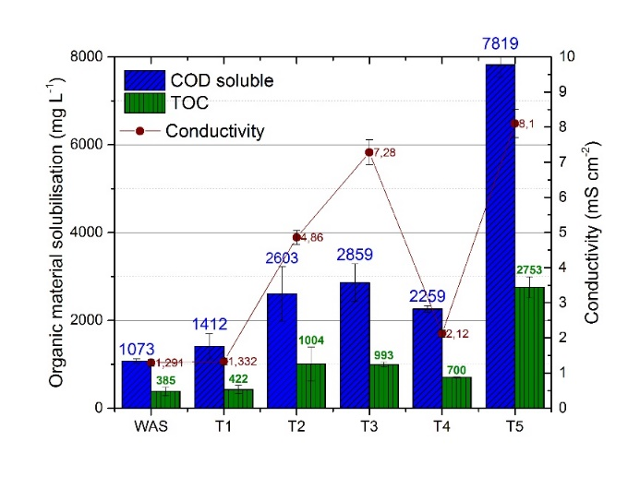
Figure 1. Measurements of soluble chemical oxygen demand (COD) and total organic carbon (TOC) obtained before and after different pretreatments on WAS electro-oxidation.

Electro-oxidation efficiency as pretreatment was greatly enhanced by the applied conditions. Treatment T1, where the conductivity of the system remained intact, reported higher soluble COD values, between those measured for this sample and the control (WAS). Treatments T2 and T3 evaluated the effect of increasing conductivity after the addition of Na₂SO₄ and reported a twofold increase when compared with the control sample. However, the increment in the concentration of the sulphate salt did not report a great increase in the solubilisation of the organic material.

The performance of electro-oxidation pretreatment was also evaluated under acidic (T4) and alkaline (T5) conditions. The latter pretreatment test had the best results in solubilisation as previously commented, probably associated with the intrinsic enhancement of conductivity provided by the addition of the alkaline solution to increase the pH of the reactor to 10 units.

Several authors observed the effectiveness of electro-oxidation treatment of WAS regarding its solubilisation and further improvement in anaerobic digestion. The electro-oxidation experiments by Feki et al. (2015) improved COD solubilisation by 28% with their experiments, conducted at pH 7 and current density of 2.5 mA cm^{–2} for 2 h. A study performed by Barrios et al. (2017) showed a decrease in total COD and an increase in soluble COD at optimal pretreatment conditions (28.6 mA cm^{–2}), leading to higher methane production (up to 76%–80%) after anaerobic digestion. In contrast, Pérez-Rodríguez et al. (2019) reported that different operating conditions applied for sludge electro-oxidation (current density ~28.6 mA cm^{–2} for 30 min) resulted in maximal solubilisation of just 1.78%.
The results from the present work differed (with lower values) from those reported by other authors, possibly attributed to lower current density and shorter treatment time applied. Current density is directly associated with the number of generated hydroxyl radicals (that react with organic matter). This parameter and pretreatment time are well-known factors for improving solubilisation, but any increase in these two parameters also translates into a boost for energy demand, thereby reducing the technical feasibility of this process.

Electro-oxidation pretreatment could contribute to the release of soluble organic matter from sludge without affecting the total content of organic compounds under the test conditions. Complex organic molecules in waste are converted into simpler forms that become easily accessible for acetogenic bacteria to generate VFAs. Figure 2 shows the obtained increase in VFA concentration after pretreatment, which was also on par with the observed TOC and soluble COD values. Three types of short-chain VFAs were mainly measured (acetic acid, propionic acid, and butyric acid), with the highest concentration corresponding to acetic acid. EPS and cell membrane disintegration exposed the inner organic material (carbohydrates and proteins) that was then released into the liquid phase, contributing to an increased content of short-chain fatty acids associated with sludge pretreatment (Li et al., 2019).
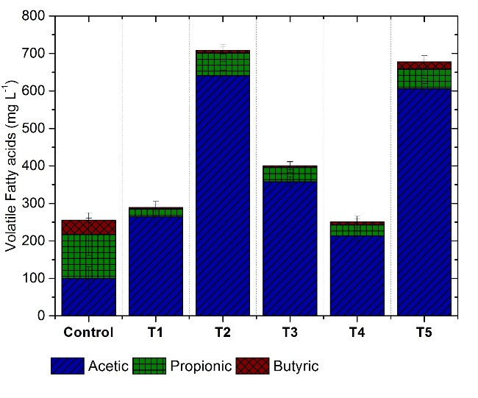
Figure 2. Volatile fatty acid concentration before and after electro-oxidation experiments.

3.2. Anaerobic Digestion Optimisation

Cumulative methane production curves obtained from the different batch assays are shown in Figure 3. An increase in methane yield was observed with the application of pretreatments (T5, T1, T4), and a decrease with the application of Pretreatments T2 and T3 (Na₂SO₄ addition). The adjustment of pH to 7 with the addition of an alkaline solution (T5) improved methane yield by ~18%.
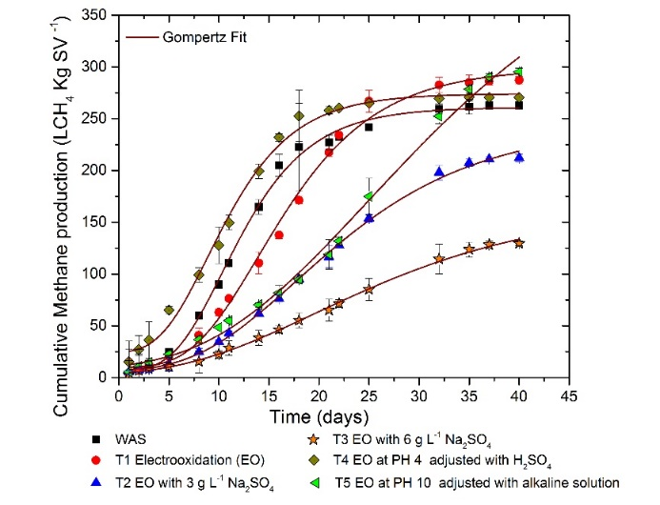
Figure 3. Cumulative methane production and fitted curves of sample after electro-oxidation pretreatment.

Sludge hydrolysis has been regarded as the rate-limiting step in the anaerobic digestion of particulate substrates; however, in this case, improvement in the solubilisation of organic matter probably improved the hydrolysis rate due to an increase in the amount of readily available compounds (VFAs). Acetic acid is a direct substrate for methanogens, and it is transformed into methane via methanogenesis. Thus, it can be assumed that the increase in acetic acid production was directly associated with the increase in methane production.

Table 2. Kinetic parameters of Gompertz adjustment.

Sample | P_{max}  (L_{methane} kgVS^{–1}) | R_{max}  (mL d^{–1}) | λ (Days)
WAS | 253 ± 15 | 19.21 ± 1.23 | 5.44 ± 0.21
T1 | 288 ± 12 | 16.15 ± 1.42 | 7.30 ± 0.23
T2 | 237 ± 10 | 8.65 ± 1.33 | 7.63 ± 0.24
T3 | 162 ± 6 | 4.52 ± 0.89 | 6.40 ± 0.15
T4 | 249 ± 15 | 19.35 ± 2.65 | 6.11 ± 0.13
T5 | 298 ± 13 | 10.36 ± 1.89 | 9.25 ± 0.28

The fitted curves of the Gompertz model are also represented in Figure 3, with the model parameters summarised in Table 2. The curves of methane production showed a sigmoidal profile with an initial lag phase that may be associated with the complexity in the substrate structure (i.e., extracellular polymeric substance and cell wall). Although sludge pretreatment improved the specific methane potential (T1, T4, T5), the lag phase obtained from the pretreated experiments was greater than the one obtained from the control systems. This behaviour was presumably an indication of the microbial system needing time to adapt to the new acidic conditions or to the higher levels of salinity caused by the addition of salts during the electro-oxidation tests.

3.3. Effect of Electro-Oxidation Post-Treatment on Sludge Dewaterability and Stability

The effect of electro-oxidation applied as a post-treatment was tested under five different conditions, while parameters such as particle size reduction and dewaterability characteristics were employed to evaluate the effectiveness of the process. Figure 4. shows the enhancement on the solubilisation of the organic matter compared to the raw digestate. The values of organic content of the digestate sample were 417 ± 12 mg L^{–1} TOC (soluble fraction) and 1158 ± 57 mg L^{–1} for soluble COD. The application of electro-oxidation to the digestate sample led to a slight increment of TOC and COD measurements for the soluble fraction that was more noticeable after 1 hour of post-treatment (P5). This enhancement can be explained by the extended time of applied treatment (despite the lower value of current density (6.8 mA/cm^{–2}) or conductivity associated with this test). The obtained results after 5 minutes of treatment did not show significant differences between them, with all treated samples having similar conductivity and current density values of 5.5 (P1), 10.7 (P2), and 11.7 mA cm^{–2} (P3). Nevertheless, the P4 treatment showed the highest solubilisation compared to previous treatments (P1, P2, and P3), which was due to current density (18.8 mA cm^{–2}) and conductivity (16.6 mS cm^{–2}) being applied on this test, with almost double values those of other treatments.
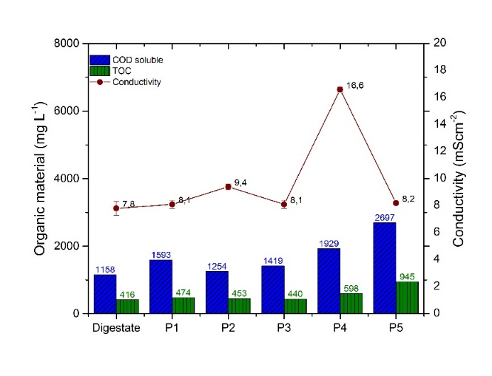
Figure 4. Organic material content before and after electro-oxidation post-treatment of sludge digestate.

Drying curves reporting on water distribution show three characteristic zones. The upper one corresponds to free water associated with solid particles, the middle one is associated with interstitial water (trapped inside interstitial spaces of flocs and micro-organisms), and the lower one refers to chemically bound water (Supplementary Figure S1a,b). Interpretations of these curves, which resulted from the digestate sample and the five electro-oxidation tests, were adapted from Kopp and Dichtl (2001). Post-Treatment P5 showed faster loss of interstitial water compared to the other runs. This result was to be expected since P5 had the lengthiest treatment time (60 min), whereas the other tests were tested for only 5 minutes. This longer current and voltage exposure also improved the release of interstitial and bound water, requiring a shorter overall period for eliminating water. However, in a real-world scenario, the excessive energy demand from this post-treatment prevents it from being an economically feasible option. For that reason, the P4 method is a realistic candidate, whereby a treatment time of 5 minutes showed the second-best result in water release rate and required time for sample drying.

Table 3 discloses the associated values with the release of water from the different samples and the parameters associated with the fit of water release curves to an S-shape logistic function. In this case, the release of water is expressed as a percentage and represented versus drying time. As observed in Figure S1a, the release of free water was facilitated by the post-treatment method, which had a significant effect on the necessary energy for reducing sludge humidity. The digestate and the P1 treatment needed the longest time to eliminate free water contained in their matrix. These two samples displayed the highest value for the time required to remove 20% of the mass (water) and for parameter t₀, which indicated the time where 50% of mass loss had occurred. In general, all post-treatments (P1–P4) reported similar values for the rate of water release (k). The digestate submitted to Post-Treatment P4 presented a significantly lower value of Time] _{mass loss_20%} and t₀. Considering the short duration of this treatment, this seems to have been related to modification of the structure of the sludge matrix. The P5 post-treatment demonstrated the lowest values for the same parameters, and the highest values for growth rate k as an indicator of accessible humidity removal in this sample. Overall, using the logistic model to calculate the drying behaviour of a sludge sample can function as a quantitative tool for evaluating thermal performance (see Figure S1b).
Table 3. Values associated with water release for different evaluated samples.
 | Time ] _{mass loss_20%} (s) | L | t₀ | k | Adj R²
Digestate | 540 | 100.9 ± 0.5 | 799.0 ± 6.2 | 0.00566 ± 0.00017 | 0.997
P1 | 566 | 100.8 ± 0.5 | 792.8 ± 6.1 | 0.00635 ± 0.00021 | 0.996
P2 | 506 | 100.7 ± 0.4 | 750.5 ± 5.4 | 0.00600 ± 0.00017 | 0.997
P3 | 510 | 100.6 ± 0.3 | 770.2 ± 4.2 | 0.00535 ± 0.00010 | 0.998
P4 | 463 | 100.8 ± 0.5 | 702.2 ± 6.7 | 0.00630 ± 0.00023 | 0.995
P5 | 347 | 100.4 ± 0.3 | 504.2 ± 3.0 | 0.00921 ± 0.00022 | 0.998

The results from particle size analysis are presented in Supplementary Figure S2a,b. Analysis of the digestate sample showed a main peak at around 30µm, and two lower peaks at approximately 200 and 500 µm with a dispersion of larger-diameter particles, which may be explained by the presence of aggregates (Supplementary Figure S2a). Post-treated samples displayed a similar main peak of 30 μm, but did not show any longer peak centred at 500 µm except for the P1 treatment, which maintained the 200 μm peak (Supplementary Figure S2b). All of the post-treated samples presented similar distributions, with a small shift to the left in the area of the main peak (regarding particle diameter scale).

The P4 (highest applied current density) and P5 (maximal electro-oxidation duration) post-treatments resulted in smaller-sized particles. This is highlighted by the lower values of the mean particle size parameter (Table 4). Table 4 also contains other indicators, such as the median value of particle size distribution and specific surface area (SSA). Post-treatment electro-oxidation caused a significant increase in SSA values and a decrease in particle size on all of the tested conditions, but it seemed to not affect pH and conductivity values.

Table 4. Dewatering parameters after electro-oxidation post-treatment.
Parameter | Current Density  mA cm^{–2} | Mean (µm) | Median  (µm) | SSA (cm² mL ^{–1}) | VS removal (%) |  | TS (g/kg) | CSTs (s) |  |  | SRF × 10¹² (m/kg)
Digestate | n/a | 61.5 ± 1.23 | 35.0 ± 1.06 | 2874 ± 57 | n/a | 21.8 ± 0.65 |  |  | >2000 |  | 4.17 ± 0.05
P1 | 5.5 ± 0.01 | 38.8 ± 0.77 | 30.8 ± 0.99 | 3539 ± 65 | 8.8 ± 0.01 |  | 19.4 ± 0.50 |  |  | 914 ± 30 | 3.75 ± 0.06
P2 | 10.7 ± 0.01 | 37.8 ± 0.66 | 29.1 ± 1.02 | 3758 ± 45 | 9.2 ± 0.03 |  | 19.0 ± 0.56 |  |  | 873 ± 25 | 3.24 ± 0.04
P3 | 11.4 ± 0.01 | 36.7 ± 0.65 | 29.9 ± 1.01 | 3752 ± 68 | 9.8 ± 0.02 |  | 18.8 ± 0.68 |  |  | 753 ± 28 | 3.00 ± 0.08
P4 | 18.8 ± 0.01 | 35.6 ± 0.58 | 29.6 ± 0.95 | 3803 ± 65 | 9.7 ± 0.03 |  | 18.5 ± 0.63 |  |  | 625 ± 26 | 2.89 ± 0.05
P5 | 6.8 ± 0.01 | 34.6 ± 0.54 | 28.7 ± 1.02 | 3934 ± 50 | 22.2 ± 0.02 |  | 12.0 ± 0.59 |  |  | 348 ± 35 | 2.02 ± 0.03

Zeng et al. (2019) also observed a decrease in volumetric particle size percentage as voltage increased from 0 to 15 V. This transformation was related to the fragmentation of sludge flocs and the destruction of microbial cells, leading to a decrease in aggregation and, as a consequence, lower values of mean particle size.
After sludge stabilisation, dewatering is required for WAS disposal for reducing handling costs regardless of its end use. The main parameters related to sludge dewaterability are also summarised in Table 4. VS removal was analogous to the increase in electro-oxidation time from 5 to 60 minutes (P5). VS removal among the post-treated samples ranged from 8.8% to 22.2% (calculated according to Equation (4)), with the P5 post-treatment reaching the highest value. The electro-oxidation treatment of the digestate decreased all CST (up to 70%) and SRF values (up to 50%) compared to those obtained from the raw digestate. The highest values were derived from the digestate sample (control), suggesting lower dewaterability (or filterability). The results hinted that the higher the applied current density, the better the dewaterability outcome of the post-treatment would be. Post-Treatment P4 improved its dewaterability performance with a 5 minute application because of the combined effect of pH increase (to 10 units) and higher current density. Post-Treatment P5 showed the highest dewatering ability since the duration of the treatment had a positive impact on dewaterability parameters. However, as previously mentioned, the long duration of the post-treatment (60 min) renders this option an unfeasible strategy due to unprofitable energy demands.
Different authors studied dewaterability enhancement after testing several types of treatments. Yu et al. (2009) used microwave irradiation for improving dewatering characteristics by applying different energy loads (by varying power and time). A decrease in 34% was seen for the SRF when samples were subjected to 900 W of ionising radiation (5.39 × 10⁹ m/kg untreated sludge down to 1.84 × 10⁹ m/kg). In a different study, Erdincler and Vesilind (2000) carried out pretreatment employing thermal and ultrasound techniques. These studies managed to disrupt flocs and disintegrate aggregates, thus reducing the CST from 19.7 to 15.2 and 17.1 s when thermal and ultrasound treatments were tested, respectively. Advanced chemical oxidant reactions as Fenton treatment were studied by Buyukkamaci (2004) as a technique for improving dewatering, reporting a decrease of 44% in CST values. In the present research, this particular parameter was improved by decreasing the CST from >2000 to 625.8 (P4) and 348.9 s (P5).
Raynaud et al. (2012) found that pH is also an important factor when evaluating sludge particle size distribution and dewaterability characteristics. High pH values favour the breakdown of EPS and the release of fine particles, which are known to cause clogging problems in filtration media, whereas the decrease of pH promotes floc aggregation, improving filterability. Filterability depends on the amount of supracolloidal substances and not directly on the particle size of the sample, as observed by Karr and Keinath (1978). However, the modification of pH on a large scale has a significant effect on operating costs, and it is an added bottleneck for sludge end disposal. In the present study, where the pH in the P4 post-treatment was fixed to 10 units, dewaterability parameters were enhanced, but the high value of pH can be challenging when finding a final disposal solution.
3.4. FTIR Analysis Results
FTIR analysis was carried out to assess the effect of digested sludge stability after the application of electro-oxidation as post-treatment. Figure 5 presents the spectra obtained from inoculum, digestate, and the obtained samples when the digested sludge was submitted to the different post-treatments (P1–P5). Main absorbance bands and assignments of FTIR spectra were performed using previously reported data for different digestates available in the literature (Martínez et al., 2016, 2012; Provenzano et al., 2011).
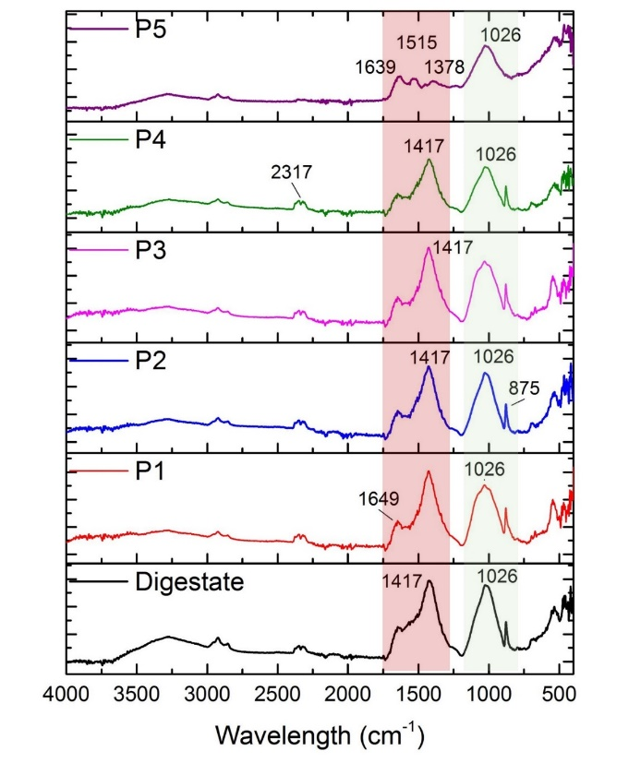
Figure 5. FTIR spectra of sludge samples before and after electro-oxidation (EO) post-treatment.

The digested sludge was characterised by a broad and midintense band in the region of 3920–2890 cm^{–1}. This band was attributed to O–H groups due to the stretching vibration of carboxylic, phenolic, or alcoholic groups. The O–H stretching vibration was due to intramolecular hydrogen bonds in cellulose. The N–H vibration of amine and aromatic amine from proteins and peptides in this region is also characteristic (Kataki et al., 2017; Kowalski et al., 2018; Provenzano et al., 2011). Visible bands at 2925 and 2851 cm^{–1} were attributed to asymmetrical –C–H stretching vibration of aliphatic bonds in fats and lipids (Fels et al., 2013; Cuetos et al., 2010). The doublet band at 2345 cm^{–1} was ascribed to the unavoidable presence of CO₂ in the FTIR chamber (Hong et al., 1995). Visible bands were observed at 1633 and 1648 cm^{–1} that were related to aromatic C=C bonds, C=O in primary amide, ketone, and quinone groups, with the region at 1750–1500 cm^{–1} recognised as the protein band (Martínez et al., 2015; Provenzano et al., 2011; Kataki et al., 2017).
The high-intensity bands at 1416 and 1435 cm^{–1} in Figure 6 were attributable to C–H stretching in aliphatic structure, and the intense band at 1029 and 1027 cm^{–1} can possibly be addressed to C=O stretching in polysaccharides (Ramamurthy and Kannan, 2007; Naumann et al., 2010). The band at 875–876 cm^{–1} was assigned to the presence of inorganic carbonates. The region at 600–500 cm^{–1} is characteristic of phosphate absorption (Smidt et al., 2002).
Differences between the obtained spectra from the digestate and post-treated digestate samples were associated with the lower intensity recorded for the main bands of the post-treated samples. The peak at 1649 cm^{–1} (related to aromatic C=C bonds or C=O in primary amides) had a marked presence in post-treated samples, and it was still discernible when the most severe post-treatment was evaluated. However, the band located at 1417 cm^{–1} (aliphatic structure), whose presence was easily observed in all spectra, was no longer observed in the P5 sample. This was interpreted as a measurement of the severity of this post-treatment in removing long-chain molecules by oxidation through OH radicals. A similar fate was observed for the peak at 875 cm^{–1} (assigned to the presence of inorganic carbonates), which was no longer visible for this sample.
Electro-oxidation enhanced the stability of digested sludge by oxidising the aliphatic structures present in digested samples, and modifying the protein structure of the sample. This is the case for those treatments performed under extreme conditions, that is, P4 (higher current density) and P5 (extended treatment time). In the former, modifications in FTIR spectra were hardly noticeable when comparing them with the post-treated samples, but changes in the protein region of the spectra (a small decrease in signal intensity at around 1500–1600 cm^{–1}) may have been responsible for the higher release of water when analysing the drying curves. The P5 sample, on the other hand, provided a better understanding of the attained changes thanks to the post-treatment. The significant oxidation of the sample was easily observed from its spectrum, explaining the relevant impact of Post-Treatment P5 on drying behaviour.
4. Conclusions
Electro-oxidation was studied as a pre- and post-treatment alternative for improving digestion performance and sludge handling. In the former, electro-oxidation proved to be a suitable way for enhancing the hydrolysis of sewage sludge by favouring the solubilisation of organic matter, hence aiding in the anaerobic degradation of complex compounds. The application of electro-oxidation on WAS before anaerobic digestion caused cell membrane damage, releasing inner-cell materials accessible to anaerobic microflora, and facilitating degradation. Methane yield was increased by 18% as result of pretreatment under alkaline condition (T5), although biogas production rate was lower (10.36 ± 1.89 mL d^{–1}) and the lag phase was higher (9.25 ± 0.28 d) compared to those for the control (19.21 ± 1.23 mL d^{–1} for gas production rate and 5.44 ± 0.21 d for lag phase).
The use of electro-oxidation as the post-treatment of digested WAS proved to have a significant effect regarding rheological behaviour, particle size reduction, and dewaterability properties, increase in specific surface area, and improvement on characteristics such as capillary suction time (CST) and specific resistance to filtration (SRF). Future work will focus on evaluating the benefits of these latter characteristics and the effect on energy demand in a WWTP.

